Admin Use Case Diagrams and Tables:
- View Courses:
Use Case Diagram:
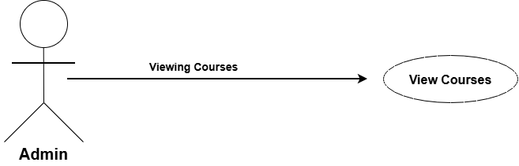
Use Case Description:
Use Case ID
Use Case Name | View Allocated Courses
Description | Admin view the list of courses allocated to students.
Primary Actor | Admin
Pre-Condition | Admin is logged into the system and courses have been allocated to students.
Post-Condition | System display the list of allocated courses.
Basic Flow | Actor Action | System Action
 | - Admin clicks on "View Courses" option  - Admin selects a student / class to view courses | - System retrieves allocated courses from database  - System displays the list of allocated courses for the selected student
Alternate Flow | - A1 - No Courses Allocated: If no courses are allocated to the selected student, system displays message "No courses allocated yet."

- View Exam:
Use Case Diagram:

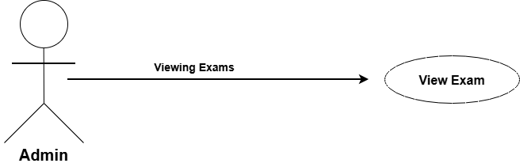
Use Case Description:
Use Case ID
Use Case Name | View Exam
Description | Admin views the list of exams created by faculty for a specific course and academic session.
Primary Actor | Admin
Pre-Condition | Admin is logged into the system. Exams have already been created by Faculty.
Post-Condition | System displays the list of exams.
Basic Flow | Actor Action | System Action
 | - Admin clicks on "View Exam" option  - Admin selects Course / Academic Session | - System retrieves exams from database  - System displays the list of exams for the selected course
Alternate Flow | - A1 - No Exam Found: If no exam is created for the selected course, system displays message "No exam found."

- Exam Results:
Use Case Diagram:
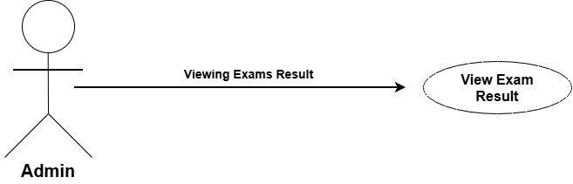
Use Case Description:
Use Case ID
Use Case Name | View Exam Result
Description | Admin views the exam results of students for a specific exam and course.
Primary Actor | Admin
Pre-Condition | Admin is logged into the system. Exam has been conducted and results have been uploaded by Faculty.
Post-Condition | System displays the exam results.
Basic Flow | Actor Action | System Action
 | - Admin clicks on "View Exam Result" option  - Admin selects Exam and Course  - Admin clicks on "View Result" | - System displays list of exams  - System retrieves results from database  - System displays the list of student results with marks
Alternate Flow | - A1 - No Result Found: If results are not uploaded yet for the selected exam, system displays message "No result found."  - A2 - No Exam Selected: If Admin does not select any exam, system displays message "Please select an exam."

- Exam Log:
Use Case Diagram:

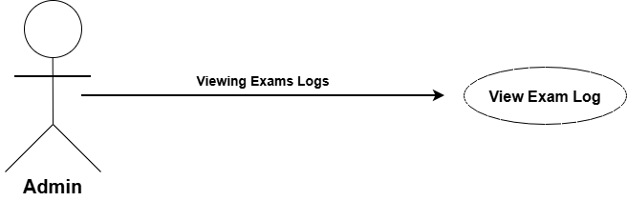

Use Case Description:
Use Case ID
Use Case Name | View Exam Log
Description | Admin views the log / history of exams, including who created the exam and when it was created.
Primary Actor | Admin
Pre-Condition | Admin is logged into the system. Exam logs are available in the system.
Post-Condition | System displays the exam log list.
Basic Flow | Actor Action | System Action
 | - Admin clicks on "View Exam Log" option  - Admin selects Exam / Date | - System retrieves exam logs from database  - System displays the log details - Created By, Date, Time, Changes
Alternate Flow | - A1 - No Log Found: If no log is available for the selected exam, system displays message "No log found."  - A2 - No Exam Selected: If Admin does not select any exam, system displays message "Please select an exam."

- Attendance:
Use Case Diagram:

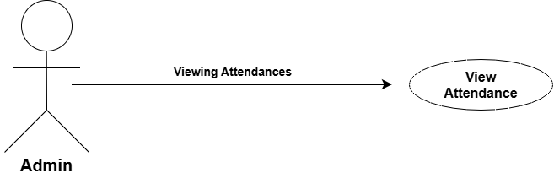

Use Case Description:
Use Case ID
Use Case Name | View Attendance
Description | Admin views the attendance record of students for a specific course and date.
Primary Actor | Admin
Pre-Condition | Admin is logged into the system. Attendance has been marked by Faculty.
Post-Condition | System displays the attendance record.
Basic Flow | Actor Action | System Action
 | - Admin clicks on "View Attendance" option  - Admin selects Course and Date  - Admin clicks on "View" | - System displays list of courses  - System retrieves attendance from database  - System displays attendance list with Present / Absent status
Alternate Flow | - A1 - No Attendance Found: If attendance is not marked for the selected date, system displays message "No attendance found."  - A2 - No Course Selected: If Admin does not select any course, system displays message "Please select a course."

- View Academic Event:
Use Case Diagram:

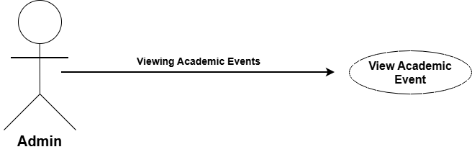

Use Case Description:
Use Case ID
Use Case Name | View Academic Event
Description | Admin views the list of academic events.
Primary Actor | Admin
Pre-Condition | Admin is logged in. Events already exist.
Post-Condition | System displays the events.
Basic Flow | Actor Action | System Action
 | - Admin clicks on "View Academic Event"  - Admin selects Academic Session | - System retrieves events from database  - System displays list of events
Alternate Flow | - A1 - No Event Found: If no event is created for the selected session, system displays message "No event found."  - A2 - No Session Selected: If Admin does not select any academic session, system displays message "Please select an academic session."

- Update Academic Event:
Use Case Diagram:
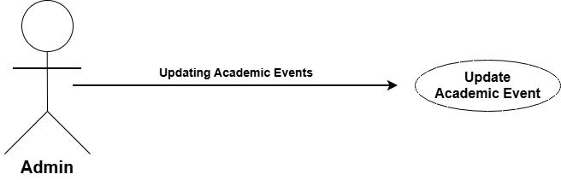

Use Case Description:
Use Case ID
Use Case Name | Update Academic Event
Description | Admin updates / edits the details of an existing academic event, like date, title, or description.
Primary Actor | Admin
Pre-Condition | Admin is logged in. Event already exists.
Post-Condition | Event details are updated and saved.
Basic Flow | Actor Action | System Action
 | - Admin clicks on "View Academic Event"  - Admin selects an Event and clicks "Edit"  - Admin changes Title / Date / Description  - Admin clicks on "Update" | - System displays list of events  - System displays event form with old data  - System validates new details  - System saves changes and displays "Event Updated Successfully"
Alternate Flow | - A1 - Missing Details: If the Admin leaves any required field empty, the system displays the message "Please fill all required fields."  - A2 - No Changes Made: If the Admin clicks on "Update" without making any changes, the system displays the message "No changes made."  - A3 - Event Not Found: If the selected event is deleted or not available, the system displays the message "Event not found."

- Delete Exam Log:
Use Case Diagram:
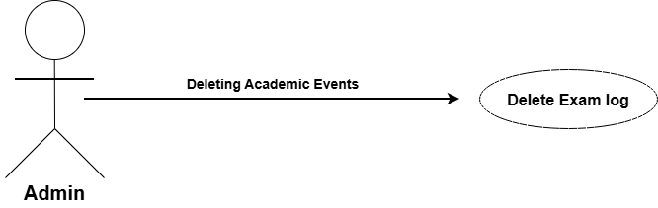

Use Case Description:
Use Case ID
Use Case Name | Delete Exam Log
Description | Admin deletes an existing exam log from the system.
Primary Actor | Admin
Pre-Condition | Admin is logged into the system. Exam log already exists.
Post-Condition | Selected exam log is deleted from the database
Basic Flow | Actor Action | System Action
 | - Admin clicks on "View Exam Log" option  - Admin selects an Exam Log and clicks on "Delete"  - Admin clicks on "Yes / Confirm" | - System displays the list of exam logs  - System displays confirmation message "Are you sure you want to delete this log?"  - System deletes the log and displays message "Exam Log Deleted Successfully"
Alternate Flow | - A1 - Cancel Delete: If the Admin clicks on "No / Cancel" on the confirmation message, the system cancels the delete operation and returns to the exam log list.  - A2 - Log Not Found: If the selected exam log is already deleted or not available, the system displays the message "Exam Log not found."  - A3 - No Log Selected: If the Admin does not select any exam log, the system displays the message "Please select an exam log to delete."

- Message Spam Filtration:
Use Case Diagram:
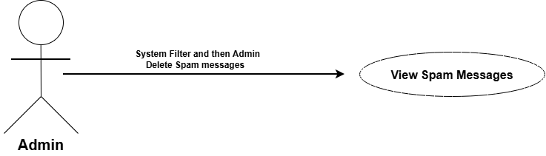

Use Case Description:
Use Case ID
Use Case Name | Filter Spam Message
Description | System automatically checks all incoming messages and filters / blocks spam messages before they reach the user.
Primary Actor | System
Secondary Actor | Admin
Pre-Condition | User is logged into the system. Spam filter is enabled.
Post-Condition | Spam message is blocked / moved to spam folder and normal message is delivered.
Basic Flow | Actor Action | System Action
 | - Student / Faculty sends a message  - –  - –  - - | - System receives the message  - System checks the message content, sender, and links against spam rules  - If message is normal, system delivers it to the receiver  - If message is spam, system moves it to Spam Folder and does not deliver it
Alternate Flow | - A1 - Spam Message Detected: If the system detects spam keywords, suspicious links, or repeated messages from the same sender, the system blocks the message and displays the message "Message blocked as spam."  - A2 - False Spam Detection: If a normal message is marked as spam by mistake, the user can mark it as "Not Spam" and the system will deliver it to the inbox.  - A3 - Admin Review: If the Admin wants to review blocked messages, the system displays the list of all spam messages for Admin to check and delete permanently.

